RESEARCH ARTICLE

IDENTIFICATION OF TICKS RESPONSIBLE FOR THE TRANSMISSION OF THEILERIA ANNULATA IN CATTLE IN DISTRICT PESHAWAR
Said Sajjad Ali Shah¹*, Azmat Hayat Khan², and Faiz ul Hassan³
¹Center of Parasitology and Poultry, Veterinary Research Institute, Peshawar, ²Center of Animal Nutrition, Livestock Research and Development, Peshawar, ³Livestock Research and Development Station, Surezi
*Corresponding author: Said Sajjad Ali Shah, Email: sajjadsheikh0695@gmail.com
ABSTRACT
Hard ticks are seen as a major hindrance to cattle’s productive performance not only because of the direct damage they cause to the skin, blood suction, and hair loss, but also because of their capacity to transmit various pathogens. The aim of this study was to morphologically identify prevalent ticks in cattle in district Peshawar and to identify the vector of Theileria annulata. For this purpose, a total of 100 cattle in three different locations (Akbar Pura, Naguman, and Warsak Road) in the district of Peshawar were examined for the presence of ticks from March to June 2022, and ticks were collected. Morphological identification of ticks revealed higher prevalence of Rhipicephalus (52.9%), followed by Hyalomma (34.1%) and Haemaphysalis (12.8%). DNA was extracted from each tick genera, and PCR was performed for the detection of Theileria annulata. PCR results revealed the presence of Theileria annulata in Hyalomma ticks only, which confirmed its role as a vector of Theileria annulata in the study area. The effect of various risk factors on the tick burden was also evaluated, and month wise occurrence was significantly higher in June (41.5%), followed by May (23.7%) and April (20.9%), and lower in March (13.8%), indicating the propagation of ticks in the hot and humid season. This study suggests that ticks belonging to the genus Hyalomma may be disease vectors for Theileria annulata; however, additional research is necessary to pinpoint the precise species of Hyalomma and to examine the role of other common ticks as disease vectors.

PAPER HISTORY
Received: 4 Sep 2025
Revised: 21 Nov 2025
Accepted: 2nd Jan 2026
Published: 6 May 2026

Keywords: Haemaphysalis, Hyalomma, Rhipicephalus, Theileria annulata, Ticks, Tick-borne pathogens

How to Cite this Article: Shah, S.S.A., A.H. Khan and F. Hassan. 2026. Identification of Ticks responsible for the transmission of Theileria annulata in cattle in district Peshawar. Journal of Veterinary Research and Production. 1(1):1-6

Introduction
Ticks of the family Ixodidae (hard ticks) are hematophagous ectoparasites that feed on the blood of various animals, including cattle, buffaloes, small ruminants, wildlife, and companion animals. Ticks are especially significant in warmer and humid environments because, if left unchecked, they can have an impact on the animals' field productivity (Rocha et al., 2019). Ticks are the most significant disease vectors in livestock globally and rank second in significance to mosquitoes in terms of human disease transmission (Ahmad et al., 2019). Additionally, compared to other arthropod species, ticks harbor a greater variety of pathogens. The significance of ticks is because they are directly harming animals by causing blood loss, deteriorating hide and skin quality, and making them weak and also act as vectors (biological and mechanical) for the spread of various diseases (Jonsson, 2006). Ticks' adaptation and prevalence vary depending on a number of environmental conditions in different parts of the world (Estrada-Peña, 2008). Pakistan’s climate is ideal for the growth and survival of tick species and many other parasitic animals’ diseases (Karim et al., 2017).
Ticks are reported to transmit many bacterial, viral, and parasitic diseases of veterinary importance, including borreliosis, rickettsial diseases, Crimean Congo Hemorrhagic fever (CCHF), theileriosis, anaplasmosis, babesiosis, ehrlichiosis, and Lyme disease, etc., throughout the world, including Pakistan (Khan et al., 2019). However, in a regional context, tropical theileriosis is the main economic disease transmitted by hard ticks in different regions of Pakistan. Tropical theileriosis, caused by Theileria annulata, is an economically important disease of cattle, causing morbidity and mortality in affected herds, and is characterized by high fever, swelling of superficial lymph nodes, anorexia, and anemia (Jabbar et al., 2015). The disease is characterized by high fever (104-106ºF), swelling of superficial lymph nodes, anorexia, anemia, etc. Theileria annulata is spread by several tick species from different genera, including Rhipicephalus, Hyalomma, Dermacentor, and Haemaphysalis, however, there is scarcity of information related to the exact tick species involved in the transmission of theileriosis, especially in the study area. Therefore, the goal of the current study was to pinpoint the precise vector that spreads Theileria annulata among cattle in the Peshawar District of Khyber Pakhtunkhwa, Pakistan.
Materials and Methods
Study area
This study was conducted in District Peshawar, which is located at latitude 34°N and longitude 71.35°E. Temperature in Peshawar averages 22ºC annually; however, it exceeds 40ºC in summer and provides ideal conditions for the propagation of hard ticks.
Collection of ticks
During the present study, engorged ticks were collected from cattle (of different ages and sex) in different areas of District Peshawar, i.e., Akbar Pura, Naguman, and Warsak Road, from March to June 2022. Ticks were collected in McCartney bottles (Fisher Scientific) containing 70% ethanol as a preservative (Atif et al., 2012).
Morphological Identification of ticks
Tick samples were identified under a stereomicroscope with the help of morphological characteristics using genus and species-specific keys mentioned by (Walker, 2003); Taylor et al. (2015).
Detection of Theileria annulata in ticks
DNA was extracted from morphologically identified ticks as per the manufacturer’s instructions (Analytik Jena innuPREP DNA Micro kit, Germany). Briefly, ticks that had been preserved were air-dried to remove any remaining ethanol and then pulverized in a pestle and mortar and then mixed with 200 µl TLS and 20 µl Proteinase K. The mixture was vortexed (VELP Scientifica, F202A0175) for 5 sec to ensure proper mixing and incubated at 50°C for 30 min. After incubation, the mixture was centrifuged at 12,000 RPM for 1 min, and the supernatant was transferred to an Eppendorf tube. Binding solution (200 µl) was added to the lysate and mixed by vortexing for 5 sec, and the mixture was poured into a spin filter and centrifuged at 12,000 RPM for 1 min. The filtrate was discarded, and 400 µl of washing solution HS was added to the spin filter and centrifuged at 12,000 rpm for 1 min. The flow-through was discarded, and 750 µl washing solution MS was added to the spin filter and centrifuged again at 12,000 RPM for 1 min. The filtrate was discarded, and the spin filter was centrifuged at 15,000 rpm for 2:30 min to remove any traces of ethanol. Finally, 80 µl of elution buffer was added to the spin filter, incubated for 1 min at room temperature, and centrifuged at 8000 RPM for 1:30 min. The eluted DNA was stored at -20°C till further use.

PCR reaction
For detection of Theileria annulata in ticks’ samples, a total of 25 µl PCR reaction was prepared by mixing 0.5 µl each of forward (5-ATGCTGCAAATGAGGAT-3) and reverse (5-GGACTGATGAGAAGACGATGAG-3) primers (Ellah and Al-Hosary, 2011), 12.5 µl SsoFast Evagreen Supermix (2×), 5 µl DNA template, and 6.5 µl PCR water. The reaction was incubated in a thermal cycler (Bio-Rad, CFX 96, Cat# 184-5384) at initial denaturation for 3 min at 95°C, followed by 35 cycles of denaturation at 95°C for 30 sec, annealing at 57°C for 3 sec, extension at 72°C for 30 sec, and a final extension at 72°C for 5 min.
Gel electrophoresis
Gel electrophoresis was performed for the confirmation of target gene amplification. An agarose gel (Bioworld, Cat# 40100104-3) (1.5%) was prepared by mixing 0.75 gm agarose powder in 50 ml 1×TBE (Thermo Scientific, B52) and boiled for 2 min. Ethidium bromide (3 µl) was added to the mixture when the temperature was lowered to 40-50°C, and the mixture was poured into a gel casting tray, and a comb was placed for well formation.
Statistical Analysis
A box and whisker plot was used to show the tick burden on cattle in the study area. Moreover, the Mann-Whitney U test was used for estimation of animal age and sex effects on tick burden, whereas the generalized linear model (GLM) was used for determining the effect of months on tick burden in cattle using SPSS (v.21).

Results
Ticks were identified morphologically with the help of a stereomicroscope as Rhipicephalus (52.9%), Hyalomma (34.1%) and Haemaphysalis (12.8%). (Fig. 1, Fig. 2).

Fig. 1: Graphical representation of morphologically identified ticks at genus level in the study area
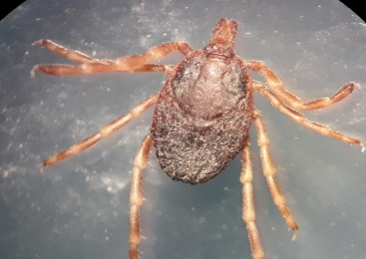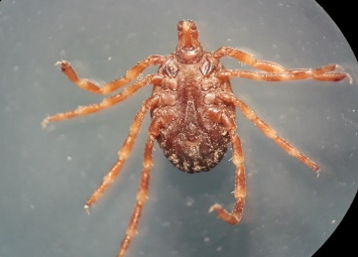
- Hyalomma female (dorsal view) | - Hyalomma female (ventral view)
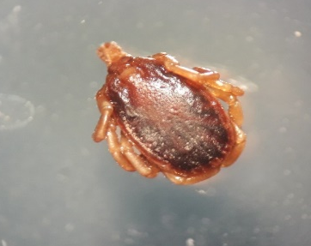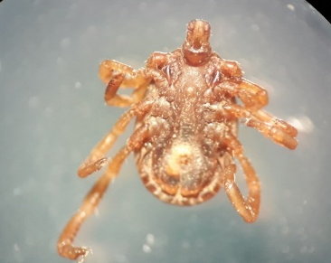
- Hyalomma male (dorsal view) | - Hyalomma male (ventral view)
Fig. 2: Photomicrographs of Hyalomma female (A&B) and male (C&D) ticks collected from cattle

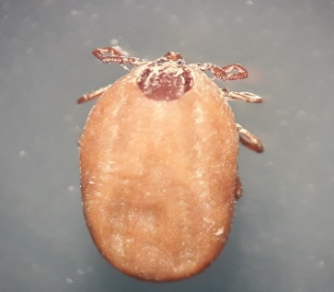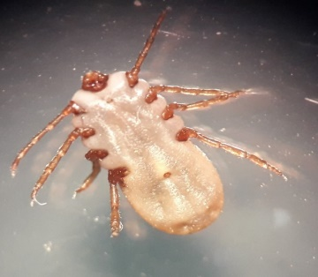
- Rhipicephalus Female (dorsal view) | - Rhipicephalus female (ventral view)
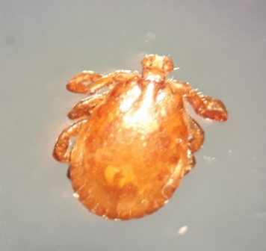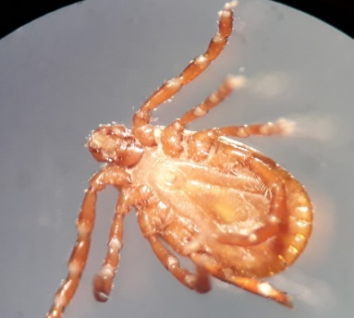
- Haemaphysalis male (dorsal view) | - Haemaphysalis male (ventral view)

Fig. 3: Photomicrograph of Rhipicephalus annulatus, (A&B) and Haemaphysalis (C&D) ticks collected from cattle

Molecular detection of Theileria annulata in ticks
After morphological identification of ticks, i.e., Rhipicephalus, Hyalomma, and Haemaphysalis, Theileria annulata was detected only in Hyalomma ticks, and the positive reaction was evaluated through the amplicon size of 785 bp during gel electrophoresis. (Fig. 4).

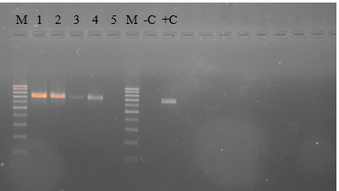

Fig. 4: Gel picture showing 100 bp DNA ladder (M) and Theileria annulata positive samples having amplicon size 785 bp (1, 2, 3, 4), NTC (-C), and Positive control (+C)
Risk factors for tick infestation
In this study, the effect of age, sex, and season on the tick burden in cattle was studied. Tick burden was significantly higher in June, followed by May and April, and lower in March. According to age, animals were grouped in two categories, i.e., below 2 years and above 2 years. The effect of age on tick burden was non-significant (P>0.05). The effect of the sex of the animal on the tick burden was also non-significant (P>0.05) in this study. (Table 1). The interquartile range (IQR) in the age group was 15-64 in the age group below 2 years and 22-40 in the age group above 2 years, and 20-42.5 in female and 32.5-42.5 in male animals. Similarly, the IQR was 12-22, 21-33, 18.75-36.25, and 35-67 in March, April, May, and June, respectively (Fig. 5).

Table 1: Tick burden in cattle of district Peshawar with respect to months, age, and sex
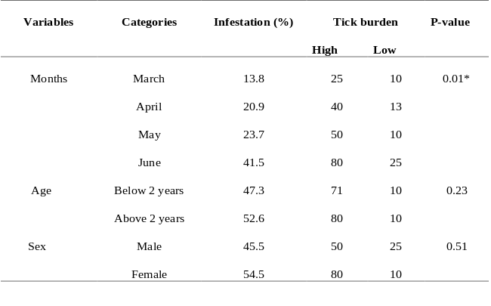
*Significance at p<0.05

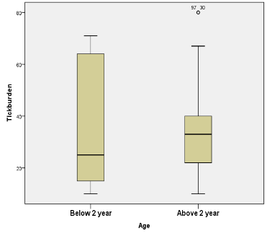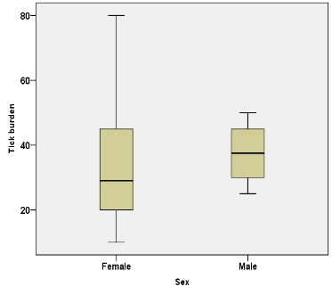
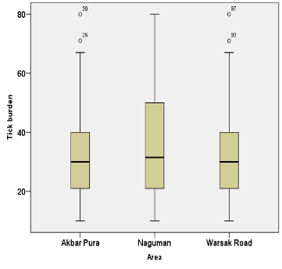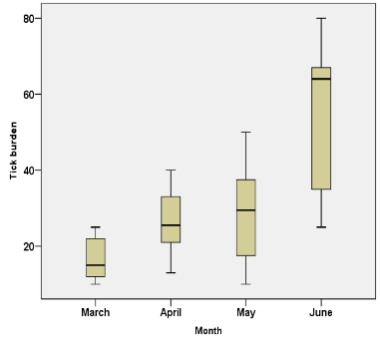
Fig. 5: Box and Whisker plot showing tick burden with respect to different risk factors, i.e., age, sex, area, and months
Discussion
Ticks and tick-borne diseases, such as theileriosis, anaplasmosis, and babesiosis, are a significant constraint for livestock productivity in the study area, as evidenced by the increased tick burden in cattle in the Peshawar District. Three genera of hard ticks, i.e., Rhipicephalus, Hyalomma, and Haemaphysalis, were identified morphologically in the study area. The prevalence of Rhipicephalus was higher in the current study, followed by Hyalomma and Haemaphysalis. Rhipicephalus as a prevalent genus is reported by various researchers throughout the country (Farooqi et al., 2017; Khan et al., 2019; Shoaib et al., 2021; Hussain et al., 2024). Although Hyalomma was the second most common tick in the current study, Farooqi et al. (2017) reported Haemaphysalis as the second most common tick genus. This discrepancy may be explained by the fact that Farooqi et al. (2017) collected ticks from various ecological zones in Khyber Pakhtunkhwa, while in the current study the ticks collected were from a limited number of animals in the District of Peshawar.
Hyalomma ticks were found to harbor Theileria annulata, establishing the connection as a vector of tropical theileriosis within the study area. Different species of Hyalomma, i.e., Hyalomma scupense, Hyalomma anatolicum, Hyalomma excavatum, etc., are reported as a potential vector for the transmission of Theileria annulata in cattle throughout the world, and also in different areas of Pakistan (Aktas et al., 2004; Zeb et al., 2019; Aouali et al., 2024; Hussain et al., 2024). Rhipicephalus and Haemaphysalis are also reported to be involved in the transmission of Theileria parva and Theileria orientalis, respectively, in different parts of the world (Ghafar et al., 2020), and Rhipicephalus also acts as a vector for anaplasmosis and babesiosis in cattle.
Different risk factors (animal age, sex, season, etc.) positively or negatively impact the tick burden, and environmental temperature is one of the main factors that determine the tick distribution. The effect of different risk factors like season (months), age, and sex on the tick burden was studied in the current study. Although age is thought to be a significant risk factor for tick infestation, the current study found no significant effect of age, which is consistent with the findings of Shoaib et al. (2021). However, other studies (Kabir et al., 2011; Singh and Rath, 2013) have reported that tick infestation was higher in young animals than in adults. This difference may have resulted from the current study's limited sample size. Tick infestation was higher in females as compared to males in the current study and is in agreement with the findings of Kabir et al. (2011) and Khan et al. (2019); however, other studies have reported higher tick infestation in males as compared to females. The possible explanation for this contradiction might be difference in proportion of male and female animals in the current study. Male animals are generally kept for breeding, and draught purpose, and that’s why receives extra attention from the owners, but in female animals resistance to ticks declines owing to pregnancy and lactation stress and exposes the animal to numerous diseases, including tick infestations (Khan et al., 2019). Ticks need hot and humid environment for their survival and propagation, and their activity increases with the increase in temperature. Tick infestation was recorded higher in June, followed by May, April, and March. Similar findings were reported by many researchers around the world (Kabir et al., 2011; Shoaib et al., 2021).

Conclusion and recommendations
It can be concluded from the findings of the current study that Rhipicephalus is the prevalent tick genus, followed by Hyalomma and Haemaphysalis, and Hyalomma is involved in the transmission of Theileria annulata.
Further investigation is needed for the identification of species of Hyalomma that act as a vector for Theileria annulata and the role of other tick species in the transmission of other tick-borne pathogens.
Acknowledgment
We are very thankful to the field staff for their help in the collection of tick samples.
Authors contributions
SSAS and FH designed the study. AHK collected the ticks’ samples. SSAS processed the samples in the lab and analyzed the data. SSAS wrote the initial draft of the manuscript, and all authors approved the final draft.
Conflict of interest
All authors declare no conflict of interest.
References

Ahmad, Z., Z. Anwar, M. Adnan, N. Imtiaz, H. Ur Rashid and F. Gohar. 2019. Collection and prevalence of ticks in cattles and buffaloes from free-range management systems of Islamabad. The Journal of Basic and Applied Zoology. 80(1):12.https://doi.org/10.1186/s41936-018-0071-1
Aktas, M., N. Dumanli and M. Angin. 2004. Cattle infestation by Hyalomma ticks and prevalence of Theileria in Hyalomma species in the east of Turkey. Veterinary parasitology. 119(1):1-8.
Aouali, N., A. Sekkai, T. Djouaher, Z. Messaoudi, H. Ziam, A. Boutellis and T. Kernif. 2024. Molecular characterization of Hyalomma scupense and its vector-borne pathogen Theileria annulata in Ksar El Boukhari (Medea, Algeria). Comparative Immunology, Microbiology and Infectious Diseases. 114:102243.https://doi.org/10.1016/j.cimid.2024.102243
Atif, F.A., M.S. Khan, H.J. Iqbal, G.M. Arshad, E. Ashraf and S. Ullah. 2012. Prevalence of Anaplasma marginale, Babesia bigemina and Theileria annulata infections among cattle in Sargodha District, Pakistan. African Journal of Agricultural Research. 7(22):302-3307.
Ellah, M. and A. Al-Hosary. 2011. Comparison of primer sets for amplification of 30 kDa merozoite surface antigen of bovine theileriasis. Journal of Animal and Veterinary Advances. 10(12):1607-1609.
Estrada-Peña, A. 2008. Climate, niche, ticks, and models: what they are and how we should interpret them. Parasitology Research. 103(Suppl 1):87-95.
Farooqi, S.H., M. Ijaz, M.H. Saleem, M.I. Rashid, M. Oneeb, A. Khan, A.I. Aqib and S. Mahmood. 2017. Distribution of Ixodid Tick Species and Associated Risk Factors in Temporal Zones of Khyber Pakhtunkhwa Province, Pakistan. Pakistan Journal of Zoology. 49(6):1937-2341.http://dx.doi.org/10.17582/journal.pjz/2017.49.6.2011.2017
Ghafar, A., A. Cabezas-Cruz, C. Galon, D. Obregon, R.B. Gasser, S. Moutailler and A. Jabbar. 2020. Bovine ticks harbour a diverse array of microorganisms in Pakistan. Parasites and Vectors. 13(1):1.https://doi.org/10.1186/s13071-019-3862-4
Hussain, A., S. Hussain, A. Yu, C. Varga, G.A. De Leo and R.L. Smith. 2024. Geographical epidemiology of Hyalomma anatolicum and Rhipicephalus microplus in Pakistan: A systematic review. PloS One. 19(8):e0309442.https://doi.org/10.1371/journal.pone.0309442
Jabbar, A., T. Abbas, H.A. Saddiqi, M.F. Qamar and R.B. Gasser. 2015. Tick-borne diseases of bovines in Pakistan: major scope for future research and improved control. Parasites and vectors. 8(1):283.
Jonsson, N. 2006. The productivity effects of cattle tick (Boophilus microplus) infestation on cattle, with particular reference to Bos indicus cattle and their crosses. Veterinary Parasitology. 137(1-2):1-10.
Kabir, M., M. Mondal, M. Eliyas, M. Mannan, M. Hashem, N. Debnath, O. Miazi, C. Mohiuddin, M. Kashem and M. Islam. 2011. An epidemiological survey on investigation of tick infestation in cattle at Chittagong District, Bangladesh. African Journal of Microbiology Research. 5(4):346-352.
Karim, S., K. Budachetri, N. Mukherjee, J. Williams, A. Kausar, M.J. Hassan, S. Adamson, S.E. Dowd, D. Apanskevich, A. Arijo, Z.U. Sindhu, M.A. Kakar, R.M.D. Khan, S. Ullah, M.S. Sajid, A. Ali and Z. Iqbal. 2017. A study of ticks and tick-borne livestock pathogens in Pakistan. PLoS Neglected Tropical Diseases. 11(6):e0005681.https://doi.org/10.1371/journal.pntd.0005681
Khan, A., N. Nasreen, S. Niaz, S. Sajjad Ali Shah, R.D. Mitchell Iii, S. Ayaz, H. Naeem, L. Khan and A.P. De León. 2019. Tick burden and tick species prevalence in small ruminants of different agencies of the Federally Administered Tribal Areas (FATA), Pakistan. International Journal of Acarology. 45(6-7):374-380.
Rocha, J.F., R. Martínez, N. López-Villalobos and S.T. Morris. 2019. Tick burden in Bos taurus cattle and its relationship with heat stress in three agroecological zones in the tropics of Colombia. Parasites & Vectors. 12(1):73.https://doi.org/10.1186/s13071-019-3319-9
Shoaib, M., I. Rashid, H. Akbar, A.A. Sheikh, S.H. Farooqi, M. Asif, M.A. Khan, S. Mahmood and F.A. Khan. 2021. Prevalence of Rhipicephalus and Hyalomma ticks in cattle and associated risk factors in three districts of Khyber Pakhtunkhwa, Pakistan. Pakistan Journal of Zoology. 53(2):777-780.https://dx.doi.org/10.17582/journal.pjz/20191025111028
Singh, N.K. and S.S. Rath. 2013. Epidemiology of ixodid ticks in cattle population of various agro-climatic zones of Punjab, India. Asian Pacific Journal of Tropical Medicine. 6(12):947-951.https://doi.org/10.1016/S1995-7645(13)60169-8
Taylor, M.A., R.L. Coop and R. Wall. 2015. Veterinary parasitology. John Wiley & Sons, UK.
Walker, A.R. 2003. Ticks of domestic animals in Africa: a guide to identification of species. Bioscience Reports Edinburgh, UK.
Zeb, J., S. Szekeres, N. Takács, J. Kontschán, S. Shams, S. Ayaz and S. Hornok. 2019. Genetic diversity, piroplasms and trypanosomes in Rhipicephalus microplus and Hyalomma anatolicum collected from cattle in northern Pakistan. Experimental and Applied Acarology. 79(2):233-243.
30

